HOMEWORK 1

One and Two Sample T tests, diagnostics, and non-parametric equivalents

Please always make your HW answers obvious at the top of the page. If I can’t find it, I can’t grade it!

Remember to do your homework in Rmd and please attempt to knit to a PDF or Word Doc with clearly stated answers to each part of the homework. You may need to download a Latex editor.

For Mac:
Download and install MacTeX: MacTeX is a comprehensive TeX distribution for macOS. You can download it from the MacTeX website.
For Windows:
Download and install MiKTeX: MiKTeX is a popular TeX distribution for Windows. You can download it from the MiKTeX website.

Please write out your null and alternative hypotheses in your HW text e.g., Null Hypothesis (H0): The means of the two groups are equal (no difference). Alternative Hypothesis (H1): The means of the two groups are not equal (there is a difference).

Datasets needed for this exercise: beak.finch, macnally

Please read how to make an R markdown and knit it into a PDF

## HOMEWORK ANSWERS
Case study 1.

1.
2.
3.
4.
5.
6.
7.
8.

Case study 2.

1.
2.
3.
4.

Case Study 1: We will use data from a classic study of evolution by Peter and Rosemary Grant
examining changes in Galapagos Finch beak size following an extreme drought in 1977. The
drought influenced the number and size of seeds on the island of Daphne Major (e.g. fewer
seeds and primarily only larger seeds). They have an impressive dataset of beak sizes for
finches hatched in 1976 (prior to drought) and 1978 (after drought) to examine evolution of
beak size in the population.

Dataset: Use the dataset “beak.finch” to answer the following questions. Data included in
the spreadsheet: year (1976, 1978), depth (beak depth in mm).

Packages you will need: car

To Install car use the packages tab and click Install. From the pop up enter car. The system will Install. Alternatively, to install an R package from CRAN using command line in the console, we can use the install.packages() function. Simply type install.packages(‘car’)

You can check the box under user library. But since your library must be loaded every time it’s best to type and run library(car) in your r markdown code chunk designated for R packages.

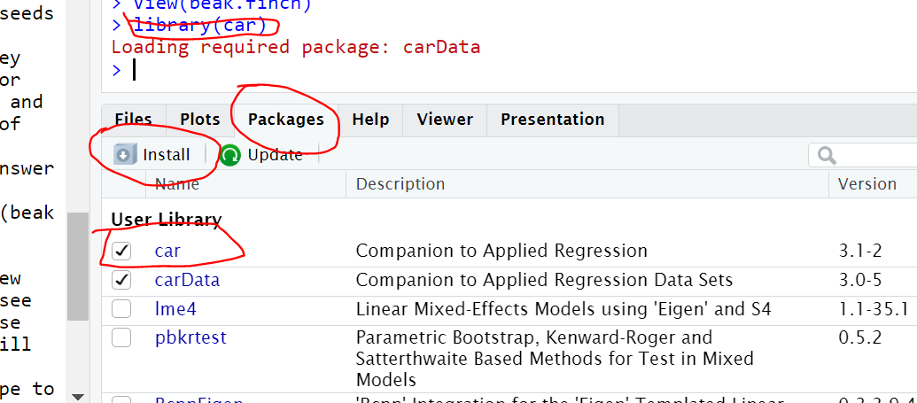

After you import the data, use str() to view the properties of each variable. In R, the str() function stands for "structure". It is used to display a concise summary of any R object.

You will see that year was imported as an integer because the values are numeric. While an integer will behave similarly to a character for many functions it is best change this vector type to a factor (to make it categorical). The code below tells R to change year to a factor and to name it
year.cat (it will create a new column in your dataframe). You should run this code and then use
your new variable, year.cat, to answer the following questions.

year.cat <- as.factor(beak.finch$year)

1. Which function would you use to generate several basic summary stats for beak depth?
A) mean()
B) nrow()
C) ncos()
D) sd()
E) summary()

2. Basic summary stats of beak depth for the year 1976 are (hint, use tapply
to get summary statistics by year):
- Min. 6.20; 1st Qu. 8.90; Median 9.70; Mean 9.47; 3rd Qu.10.20; Max.11.70
- Min. 7.10; 1st Qu. 9.60; Median 10.30; Mean 10.14; 3rd Qu. 10.70; Max. 11.70
- Min. 6.20; 1st Qu. 8.90; Median 9.70; Mean 9.47; 3rd Qu.10.20; Max.11.70
- Min. 6.20; 1st Qu. 8.90; Median 9.70; Mean 10.14; 3rd Qu.10.20; Max.11.70

3. Basic summary stats of beak depth for the year 1978 are:
A) Min. 6.20; 1st Qu. 8.90; Median 9.70; Mean 9.47; 3rd Qu.10.20; Max.11.70
B) Min. 7.10; 1st Qu. 9.60; Median 10.30; Mean 10.14; 3rd Qu. 10.70; Max. 11.70
D) Min. 6.20; 1st Qu. 8.90; Median 9.70; Mean 9.47; 3rd Qu.10.20; Max.11.70
E) Min. 6.20; 1st Qu. 8.90; Median 9.70; Mean 10.14; 3rd Qu.10.20; Max.11.70

4. Use the function "hist" to make histogram of finch beak depth for the years 1976 and 1978
(make separate histograms for each year). An appropriate description of these figures is:
- Density plots of beak depth (mm) for Galapagos finches hatched in 1976 and 1978. Based on these plots, the data appear approximately normal with some indication of a left skew. Spread of the data is slightly larger in 1976, however, overall the variances of the two groups appear approximately equal.
- Histograms of beak depth (mm) for Galapagos finches hatched in 1976 and 1978. Based on these plots, the data appear non-normal. Spread of the data is slightly larger in 1976, however, overall the variances of the two groups appear approximately equal.
- Histograms of beak depth (mm) for Galapagos finches hatched in 1976 and 1978. Based on these plots, the data appear approximately normal with some indication of a left skew. Spread of the data is larger in 1976, and the variances of the two groups do not appear equal.

5. Use the function "boxplot" to make a box plot of finch beak depth for the years 1976 and 1978
(show both years in a single figure containing two box plots). An appropriate description of this
figure is:
- Boxplot of beak depth (mm) of Galapagos Finches hatched in 1976 and 1978. Boxplot whiskers depict the 5th and 95th percentiles and boxes show the 25th and 75th percentiles with median value indicated; outliers are indicated with open circles. The spread of the beak depth appears approximately equal between the two years. Beak depth for both years is slightly left skewed, but overall the distributions appear approximately normal.
- Boxplot of beak depth (mm) of Galapagos Finches hatched in 1976 and 1978. Boxplot whiskers depict the 10th and 90th percentiles and boxes show the 25th and 75th percentiles with median value indicated; outliers are indicated with open circles. The spread of the beak depth appears approximately equal between the two years. Beak depth for both years is slightly left skewed, but overall the distributions appear approximately normal.
- Beak depth (mm) of Galapagos Finches hatched in 1976 and 1978.
- Beaks

6. Based on your results from the previous steps, choose a suitable statistical test for comparing
beak size by year.
- Two-sample T-test
- ANOVA
- Linear regression
- Correlation
- Chi-square
- Wilcoxon rank-sum test (Mann-Whitney U test)

7. Use R to run a statistical test for comparing beak size by year. What is your statistical
conclusion?
- Reject the null hypothesis that mean beak depth is equal between years
- Reject the alternative hypothesis that mean beak depth is equal between years
- Fail to reject the null hypothesis that mean beak depth is equal between years
- Fail to reject the alternative hypothesis that mean beak depth is equal between years

8. How should you describe the biological conclusion from your statistical test? If you chose Wilcox above now run Welch t test

- We found an increase in average beak depth (mm) of Galapagos Finches between birds hatched in 1976 and 1978 (t=-4.58, df=176, p = 0.001). Our data support the hypothesis of directional selection of beak size resulting in the evolution of larger beak depth 1976= 9.5 ± 1.0mm; 1978= 10.1 ± 0.9mm) in Galapagos Finches after the 1977 drought that impacted the number and size of seeds on the island of Daphne Major (e.g. fewer seeds and larger seeds after the drought).
- We found a decrease in average beak depth (mm) of Galapagos Finches between birds hatched in 1976 and 1978 (t=-4.58, df=176, p = 0.001). Our data support the hypothesis of directional selection of beak size resulting in the evolution of larger beak depth 1976= 9.5 ± 1.0mm; 1978= 10.1 ± 0.9mm) in Galapagos Finches after the 1977 drought that impacted the number and size of seeds on the island of Daphne Major (e.g. fewer seeds and larger seeds after the drought).
- We found no difference in average beak depth (mm) of Galapagos Finches between birds hatched in 1976 and 1978 (t=-4.58, df=176, p = 0.001). Our data do not support the hypothesis of directional selection of beak size after the 1977 drought that impacted the number and size of seeds on the island of Daphne Major (e.g. fewer seeds and larger seeds after the drought).

Case study 2:
Import the “macnally” spreadsheet off of Lamaku. This dataset looks at the density of two species of birds (Grey Shrike Thrush and Eastern Yellow Robin) as a function of habitat type.

1) Examine assumptions of parametric tests by creating boxplots and histograms of both bird species. Be sure to add appropriate labels to each plot. Describe the data distribution.

2) Run a one sample t test for both a 2-sided and one-sided alternative (you specify the direction) comparing the mean for GST against a mu of 5.7. Report your results. Do you accept or reject the Null in each test?

3) Run a two sample t test comparing EYR to GST (first assume equal variances, then run another test assuming unequal variances). Report results for each. Do you accept or reject the Null?

4) Now run an appropriate non-parametric two-sample test

